ĐỀ-SUY HÔ HẤP

Contents

TN2022-Y16-lần 1 2

TN2022-Y15 cũ-lần 1 2

TN2021-Y15-lần 1 3

TN2021-YLT-lần 1 4

TN2021-YLT-Lần 2 4

TN2020-Y14-Lần 1 4

TN2020-Y14-lần 2 5

TN2020-YLT 5

TN2019-Y13 5

TN2019-Y13-lần 2 6

TN2018-Y12-Lần 1 7

TN2018-Y12-Lần 2 7

TN2017-Y11-Lần 1 7

TN2019-YLT 7

# TN2022-Y16-lần 1

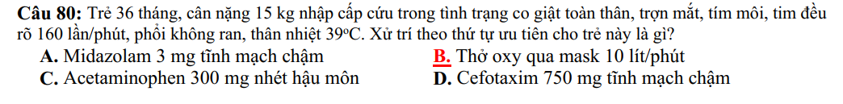

# TN2022-Y15 cũ-lần 1

# TN2021-Y15-lần 1

TN2021-Y15-lần 2

# TN2021-YLT-lần 1

# TN2021-YLT-Lần 2

# TN2020-Y14-Lần 1

# TN2020-Y14-lần 2

# TN2020-YLT

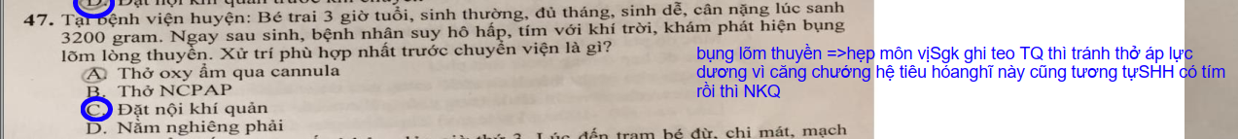

# TN2019-Y13

# TN2019-Y13-lần 2

# TN2018-Y12-Lần 1

# TN2018-Y12-Lần 2

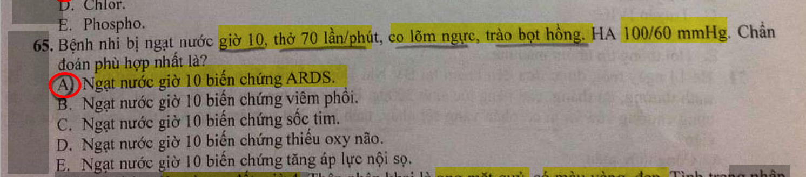

# TN2017-Y11-Lần 1

# TN2019-YLT

TN2018-YLT

